Norovirus is the leading cause of foodborne disease outbreaks in the United States. It is highly contagious and requires a very small amount to make someone sick. Transmission occurs via foodborne, person-to-person contact, airborne inhalation of vomitus droplets, and through contact with contaminated surfaces. Norovirus can survive at room temperature on surfaces for 5 days unless a disinfectant specifically made to kill Norovirus is used.
Clean-up Procedures:
1.) Close or block off an area at minimum 10 feet in all directions of the vomit or diarrhea using the ‘Caution! - Wet Floor’ signs, caution tape or safety cones.
2.) Put on personal protective equipment (PPE) in this order: disposable gown or apron, face mask, eye protection, shoe covers and disposable gloves.
3.) Immediately covered vomit or diarrhea with absorbent material or paper towels to minimize spread. If using an absorbent material, allow it to stand until all liquid is absorbed.
4.) Open garbage bag and fold it open to easily put soiled paper towels inside.
5.) Using a disposable shovel and paper towels, completely pick up all of the substance. Place it in the trash bag and seal this bag with bag ties and place in a second trash bag. Keep second trash bag open.
6.) Working from the outside of the 10-foot circle inward, apply a generous amount of bleach solution or other EPA disinfectant to all surfaces (equipment, floors, walls, chairs, tables, etc.) within the defined area. Allow to sit for 5 minutes while wet on all surfaces until air dry. After required contact time, all surfaces that are intended for food contact need to be wiped down with clean towel and plain water.
7.) Disassemble all exposed food preparation equipment within contamination area and apply disinfectant solution per manufacturer’s label. Allow surfaces to remain wet per contact time requirements on chemical manufacturer’s label instructions.
8.) Consider repeating steps 7 & 8 above as a precautionary measure to further ensure the norovirus agent is fully inactivated.
9.) All exposed food items and single service items should be discarded.
10.) Place all PPE used along with disposable mop heads, paper towels into the trash bag.
11.) Seal the bag tightly and place in the dumpster outside having a second employee who is wearing proper gloves open doors and the dumpster to prevent cross-contamination.
12.) After re-entering the facility immediately wash hands and face (giving extra attention between fingers and under fingernails) using handwashing procedures. Be sure to remove clothing and wash immediately to prevent cross contamination.

Supplies for Clean-up
You can purchase a Biohazard Kit that includes these supplies. Or you can create your own to include the following:
- ‘Caution! - Wet Floor’ signs, safety cones and/or caution tape
- Eye protection
- Disposable gloves
- Disposable mask
- Disposable plastic apron or gown
- Shoe covers
- Paper towels
- Several plastic trash bags and bag ties
- Liquid spill absorbent material (kitty litter)
- Disinfectant solution (see below)
- Buckets for cleaning solutions
- Spray bottles and/or portable hand pump spray applicators
Note: mops are not recommended for clean-up unless the mop head can be immediately discarded after use
Kit is Located: ________________

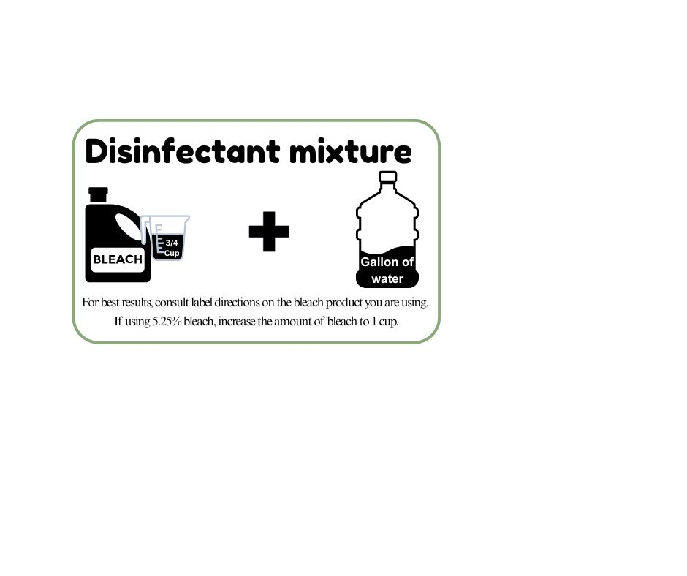
IMPORTANT!
• Only trained staff should conduct cleaning.
- Clean first, disinfect second
• Leave disinfectant on surface for at least 5 minutes
• Rinse all surfaces intended for food contact with plain water after disinfecting & before use.

* Other EPA-approved disinfectants may be used for norovirus instead of bleach, find them here:
https://www.epa.gov/pesticide-registration/list-g-epas-registered-antimicrobial-products-effective-against-norovirus

Training:
Only staff trained on proper clean-up procedures should complete the clean-up process.
These are some resources to use for training and learning the importance of detailed cleaning procedures:
https://www.youtube.com/watch?v=DueeDf9Uprg https://www.youtube.com/watch?v=sLDSNvQjXe8
IMPORTANT: Special attention should also be given to areas such as restrooms and drinking fountains and other common areas with high potential for hand contact. Even though vomitus or fecal material may not be visible, it is common for sick individuals to use public restrooms following an incident. Please ensure that you have all the supplies needed to implement this procedure.
Re-Opening Establishment or Cleaned Areas:
When the above-cited procedure is completed the establishment or area may be re-opened. If the entire establishment closes the Health Department should be contacted. It is up to the discretion of the Health Department whether a site inspection needs to be conducted prior to opening.
Monitoring Employees for Illness:
After incidents involving diarrhea and/or vomit, employees involved in clean-up procedures must be monitored for symptoms because they are at higher risk of becoming ill. This is a good time for the person in charge to remind all food employees of the employee health reporting requirements.
Incident Report:
The person in charge could generate an incident report which describes the date and time of the incident, employee(s) involved in clean-up, and a detailed description of the affected area and how it was cleaned and disinfected. It should site what food was discarded or any other materials discarded.

