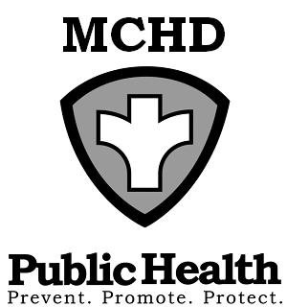
P.O. Box 181
428 Underwood Ave.
Montello, WI 53949
Telephone: (608) 297-3135
FAX: (608) 297-8923
Marquette County Health
Department

BOARD OF HEALTH
AGENDA
Tuesday, October 3, 2023 at 9:00 AM
Health & Humans Services Building or TEAMS
Remote meetings instructions below: TEAMS

Note: A citizen wishing to address the Committee/Board and attending the in-person meeting shall place his or her name on a sign-in sheet before the meeting is called to order and indicate in which town, city, or village the citizen resides or owns property prior to making a citizen comment. Those citizens attending remotely will ask to be recognized under the citizen comment portion of the meeting and will adhere to the same reporting process as those attending on-site. Civil discourse will be observed at all times.

Click here to join the meetinghttps://marquettecounty.my.webex.com/marquettecounty.my/j.php?MTID=m9b441a8ad003ca3a3c186d516e6272a0
Meeting ID: 246 500 053 680
Passcode: HYusyE

Or call in (audio only)
+1 920-770-2451
Phone Conference ID: 390 392 607#

- Call to Order
- Review and Approval of Agenda
- Minutes of August 1, 2023
- Citizen Comments
- Environmental Health Update
  - County Concerns
  - Agent Status Program Update
- New Business
  - Foot Clinic and Living Well Updates – Jenny Stelzner, PHN
  - New Citizen Member Discussion
  - Community Health Needs Assessment and Improvement Plan
  - Public Health Costing and Capacity Assessment
  - Operations Discussion

- Budgets
  - Report from Administration
  - Review Department Bills
- Upcoming Events/Issues (for discussion only)

- Adjourn

