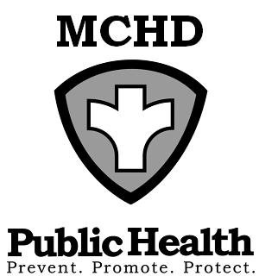
428 Underwood Ave.
Montello, WI 53949
Telephone: (608) 297-3135
FAX: (608) 297-8923
Marquette County Health
Department

BOARD OF HEALTH
AGENDA
Tuesday, December 3, 2024 at 9:00 AM
Health & Humans Services Building or WEBEX
Remote meetings instructions below: WEBEX

Note: A citizen wishing to address the Committee/Board and attending the in-person meeting shall place his or her name on a sign-in sheet before the meeting is called to order and indicate in which town, city, or village the citizen resides or owns property prior to making a citizen comment. Those citizens attending remotely will ask to be recognized under the citizen comment portion of the meeting and will adhere to the same reporting process as those attending on-site. Civil discourse will be observed at all times.
https://marquettecounty.my.webex.com/marquettecounty.my/j.php?MTID=m9c8066505f8b15a2f7e675e1c11d7097
Meeting number (access code): 2553 990 1160
Meeting password: pVPmmkpG226 (78766574 when dialing from a phone or video system)
Phone 1-408-418-9388

- Call to Order
- Review and Approval of Agenda
- Minutes of October 1, 2024
- Citizen Comments
- Environmental Health Update
  - County Concerns
  - Agent Status Program Update

- Old Business
1. Communicable Disease/Reproductive Health Update-Jessica DeRosier, PHN

- New Business
  - FSRL Program Contract
The committee may go to closed session under state statute 19.85(1)(e) Deliberating or negotiating the purchasing of public properties, the investing of public funds, or conducting other specified public business, whenever competitive or bargaining reasons require a closed session.
The committee will convene in open session under section 19.85(2) if a vote is needed on items discussed in closed session

- Budgets
  - Report from Administration
  - Review Department Bills

- Upcoming Events/Issues (for discussion only)

- Adjourn

