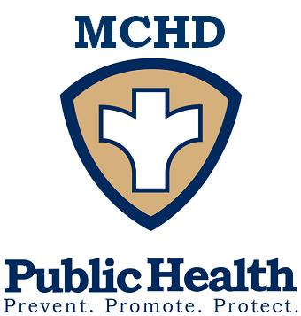
P.O. Box 181
428 Underwood Ave.
Montello, WI 53949
Telephone: (608) 297-3135
FAX: (608) 297-8923
Marquette County Health
Department

BOARD OF HEALTH
June 14th, 2022

Board chairperson, Judi Nigbor called the Board of Health meeting to order at 9 A.M. The following members were present. Judi Nigbor, Kathy Jo Locke, Suzanne McCartney, Dr. William Franks, Mike Raddatz, Nick Coenen, Kathleen McGwin and Al Gibeaut. Also, present were Jayme Sopha, Health Officer/Director, Ron Barger, County Administrator, Matt O’Connell, MIS Department, Elizabeth Reynolds, AHEC Student, and Melissa Rose, Public Health Technician.

Members Absent: Jessica Jungenberg, Environmental Health Specialists

Motion by Kathy Jo Locke, seconded by Mike Raddatz to approve the agenda as posted and handed out. Motion carried.

Motion by Mike Raddatz, seconded by Kathy Jo Locke approve the minutes of the May 3rd, 2022, Board of Health meeting. Motion carried.

CITIZEN COMMENTS
Peggy Krause addressed the BOH regarding her concerns about funding, and the COVID vaccine.

ENVIRONMENTAL HEALTH

COUNTY CONCERNS
A written report for the month of May was presented by Jayme Sopha. The month of May included the following contacts: 5 contacts-rabies program, 3 quarantine orders and 0 released from quarantine, 1 well water tests and no radon testing kits, 4 housing contacts regarding a garage roof that had collapsed, no running water, a complaint regarding the number of people and garbage at the home, and the dismantle of a mobile home.

FOOD/WATER ILLNESS
The month of May included 1 contact regarding how to correctly handle a recall on Jiffy Peanut Butter.

AGENT STATUS PROGRAM UPDATE
The month of May included 3 Marquette County inspections, and 1 re-inspection. There was 0 Waushara County inspections and 0 Green Lake County inspections. One training was attended.

OLD BUSINESS

COVID UPDATE
Jayme discussed that Marquette Counties transmission level is moderate, and there is an increase is COVID cases. Unvaccinated individuals have shown to be in worse conditions then vaccinated against COVID.

NEW BUSINESS

INTRODUCTION OF ELIZABETH REYNOLDS– AHEC STUDENT
Jayme introduced Elizabeth Reynolds our AHEC student that will be our intern for the next 8 weeks to help with the CHA/CHIP process. Elizabeth gave a brief description where she is going to school, and what she will be doing these next few weeks.

BOARD OF HEALTH ORIENTATION
Jayme presented a slideshow going over what a health department is, what they do, how they do it and what the requirements of a BOH are. Jayme let BOH members know if they would like a tour of the department to let her know and it could be arranged.

COUNTY HEALTH RANKINGS
Jayme discussed the county health rankings within our county. It goes through Length of Life, Quality of Life, Health Factors, Clinical Care, Social & Economic Factors, and Physical Environment. We are currently ranked 55th in Wisconsin, over the past few years we have moved up.

BUDGET

BUDGET REPORT FROM ADMINISTRATION – No Budget Report from Administration.

REVIEW DEPARTMENT BILLS – A voucher of expenses for the month of May 2022, was provided for the Board of Health members to review.

UPCOMING EVENTS / ISSUES (FOR DISCUSSION ONLY)
Suzanne McCartney asked Jayme if the formula shortage is something that we are seeing happening in our community. Jayme stated it is happening in our own communities.
Kathleen McGwin stated she would like to see highlighted programs, as what they are, why we do them and the results of them.

ADJOURN

Meeting adjourned by chairperson, Judi Nigbor at 10:22AM

Next Board of Health Meeting:
Tuesday, August 2nd, 2022 @ 9:00AM

Minutes submitted by Melissa Rose

