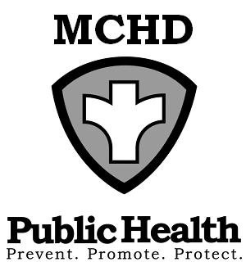
428 Underwood Ave.
Montello, WI 53949
Telephone: (608) 297-3135
FAX: (608) 297-8923
Marquette County Health
Department

BOARD OF HEALTH
AGENDA
Tuesday, June 3, 2025 at 9:00 AM
Health & Humans Services Building or TEAMS
Remote meetings instructions below: TEAMS

Note: A citizen wishing to address the Committee/Board and attending the in-person meeting shall place his or her name on a sign-in sheet before the meeting is called to order and indicate in which town, city, or village the citizen resides or owns property prior to making a citizen comment. Those citizens attending remotely will ask to be recognized under the citizen comment portion of the meeting and will adhere to the same reporting process as those attending on-site. Civil discourse will be observed at all times.
Join the meeting now
Meeting ID: 237 794 107 549 8
Passcode: xa3gf9rr
Dial in by phone
+1 920-770-2451,,994752860#

- Call to Order
- Review and Approval of Agenda
- Minutes of May 6, 2025
- Citizen Comments
- Environmental Health Update
  - County Concerns
  - Agent Status Program Update
  - REHA Program Transition

- Old Business
  - Health Educator Discussion
  - Reception Update

- New Business
  - Vaccine Cooler Update

- Budgets
  - Report from Administration
  - Review Department Bills

- Upcoming Events/Issues (for discussion only)

- Adjourn

