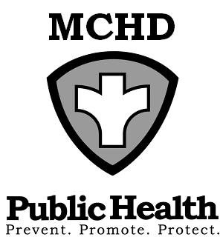
428 Underwood Ave.
Montello, WI 53949
Telephone: (608) 297-3135
FAX: (608) 297-8923
Marquette County Health
Department

BOARD OF HEALTH
AGENDA
Tuesday, September 2, 2025 at 9:00 AM
Health & Humans Services Building or WebEx
Remote meetings instructions below: WebEx
Note: A citizen wishing to address the Committee/Board and attending the in-person meeting shall place his or her name on a sign-in sheet before the meeting is called to order and indicate in which town, city, or village the citizen resides or owns property prior to making a citizen comment. Those citizens attending remotely will ask to be recognized under the citizen comment portion of the meeting and will adhere to the same reporting process as those attending on-site. Civil discourse will be observed at all times
https://marquettecounty.my.webex.com/marquettecounty.my/j.php?MTID=m0c07ec353b162977be1ea3377f906fe5
Join by meeting number
Meeting number (access code): 2557 940 7390
Meeting password: mPFpDwUT732 (67373988 when dialing from a phone or video system)
Phone: 1-408-418-9388

- Call to Order
- Review and Approval of Agenda
- Minutes of August 5, 2025
- Citizen Comments
- Environmental Health Update
  - County Concerns
  - Agent Status Program Update

- Old Business
  - Community Calendar Updates
  - CHIP Updates
  - Program Updates- Sarah Jensen, PHN

- New Business
  - Approval of Standard and High Dose Flu Vaccine Fee Increase

- Budgets
  - Report from Administration
  - Review Department Bills

- Upcoming Events/Issues (for discussion only)

- Adjourn

